FUNNEL LEAKAGE & AI BUDGET OPTIMIZATION ENGINE
IKEA Growth AI – Omnichannel Touchpoint Attribution & Friction Minimization

Dashboard Analysis Report

Live dashboard source: http://localhost:5173
Prepared from the supplied live-dashboard screenshots

1. Executive Summary
The IKEA Growth AI dashboard is designed as an omnichannel marketing decision-support system that combines funnel leakage analysis, multi-touch attribution, saturation-response modelling and AI-assisted marketing budget optimization. The dashboard moves beyond reporting historical performance by identifying where customers drop out of the journey and proposing changes to campaign allocation.
The dashboard reports 1,140,000 top-of-funnel qualified leads across six omnichannel touchpoints, total funnel value leakage of $16,452.2k, current attributed revenue of $8.39M and an AI-optimized projected ROI of 6.54x. It also identifies Delivery & Assembly as a major friction point, with a 74.6% drop-off shown on the dashboard.
At the channel level, the dashboard recommends reducing spend in Social Media Inspiration, TV & OOH Billboard Campaigns and Influencer Room Makeovers, while increasing allocation toward the IKEA Kreativ 3D Room Planner, Google Shopping & Search Ads and IKEA Family CRM & Retargeting. These recommendations are presented as model outputs based on the displayed funnel, attribution and saturation calculations.

2. Dashboard Overview
The dashboard is structured as an end-to-end analytical interface. The upper section provides headline KPIs, followed by a multi-stage funnel, channel leakage analysis, Markov attribution, saturation curves, AI budget optimization and a real-time omnichannel event stream.

2.1 Core KPIs
KPI | Displayed Value | Interpretation
Top-of-Funnel Qualified Leads | 1,140,000 | Users entering the qualified-lead/catalogue-search stage.
Total Funnel Value Leakage | $16,452.2k | Estimated value lost before checkout completion.
Current Attributed Revenue | $8.39M | Revenue attributed across the current omnichannel baseline.
AI Optimized Projected ROI | 6.54x | Projected ROI after the displayed optimization.
Delivery & Assembly Drop-off | 74.6% | Major displayed friction/bottleneck in the customer journey.

2.2 Figure 1 – Overall Dashboard and Funnel
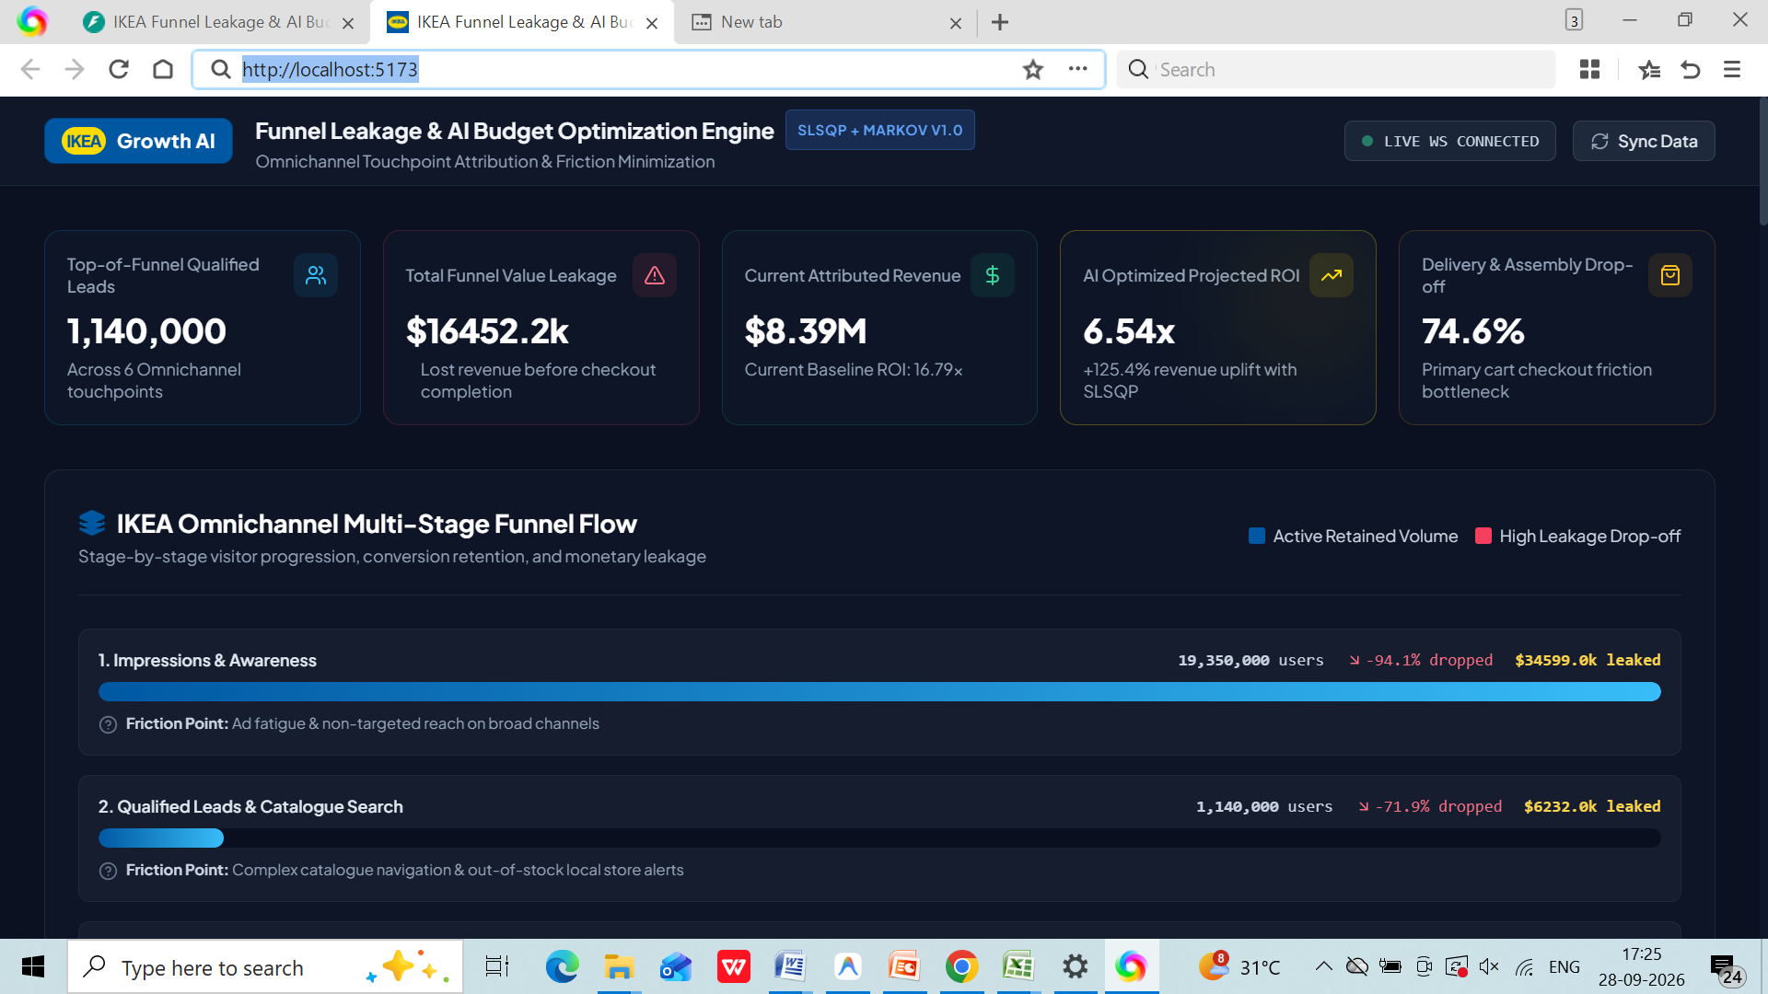
Figure 1. Overall dashboard KPI view and IKEA omnichannel multi-stage funnel flow.

3. IKEA Omnichannel Multi-Stage Funnel Analysis
The funnel visualizes customer progression from awareness through qualified search, room planning, cart activity, delivery/assembly and payment. Each stage displays retained users, drop-off and estimated leakage, along with a stated friction point.
Stage | Users | Drop-off | Leakage | Displayed friction point
Impressions & Awareness | 19,350,000 users | 94.1% dropped | $34599.0k leaked | Ad fatigue and non-targeted reach on broad channels.
Qualified Leads & Catalogue Search | 1,140,000 users | 71.9% dropped | $6232.0k leaked | Complex catalogue navigation and out-of-stock local-store alerts.
3D Room Planner & Saved Layouts | 320,000 users | 54.1% dropped | $5265.3k leaked | Mobile 3D rendering lag and dimension-measurement hesitation.
Cart Additions & Multi-Item Bundles | 146,800 users | 44.8% dropped | $8738.1k leaked | Accessory compatibility confusion.
Delivery & Assembly Surcharge Step | 81,100 users | 74.6% dropped | $17234.0k leaked | Sticker shock from delivery and assembly charges.
Order Confirmation & Payment | 20,630 users | — | — | Payment gateway timeout or financing application denial.

3.1 Funnel Interpretation
The dashboard indicates that leakage occurs at several points rather than at a single stage. The largest displayed bottleneck is the Delivery & Assembly Surcharge Step, where 74.6% of users are shown as dropping off. The dashboard associates this stage with price-related friction from delivery and assembly charges. Earlier stages also show substantial losses, particularly Awareness-to-Qualified Lead progression and the catalogue-search stage.
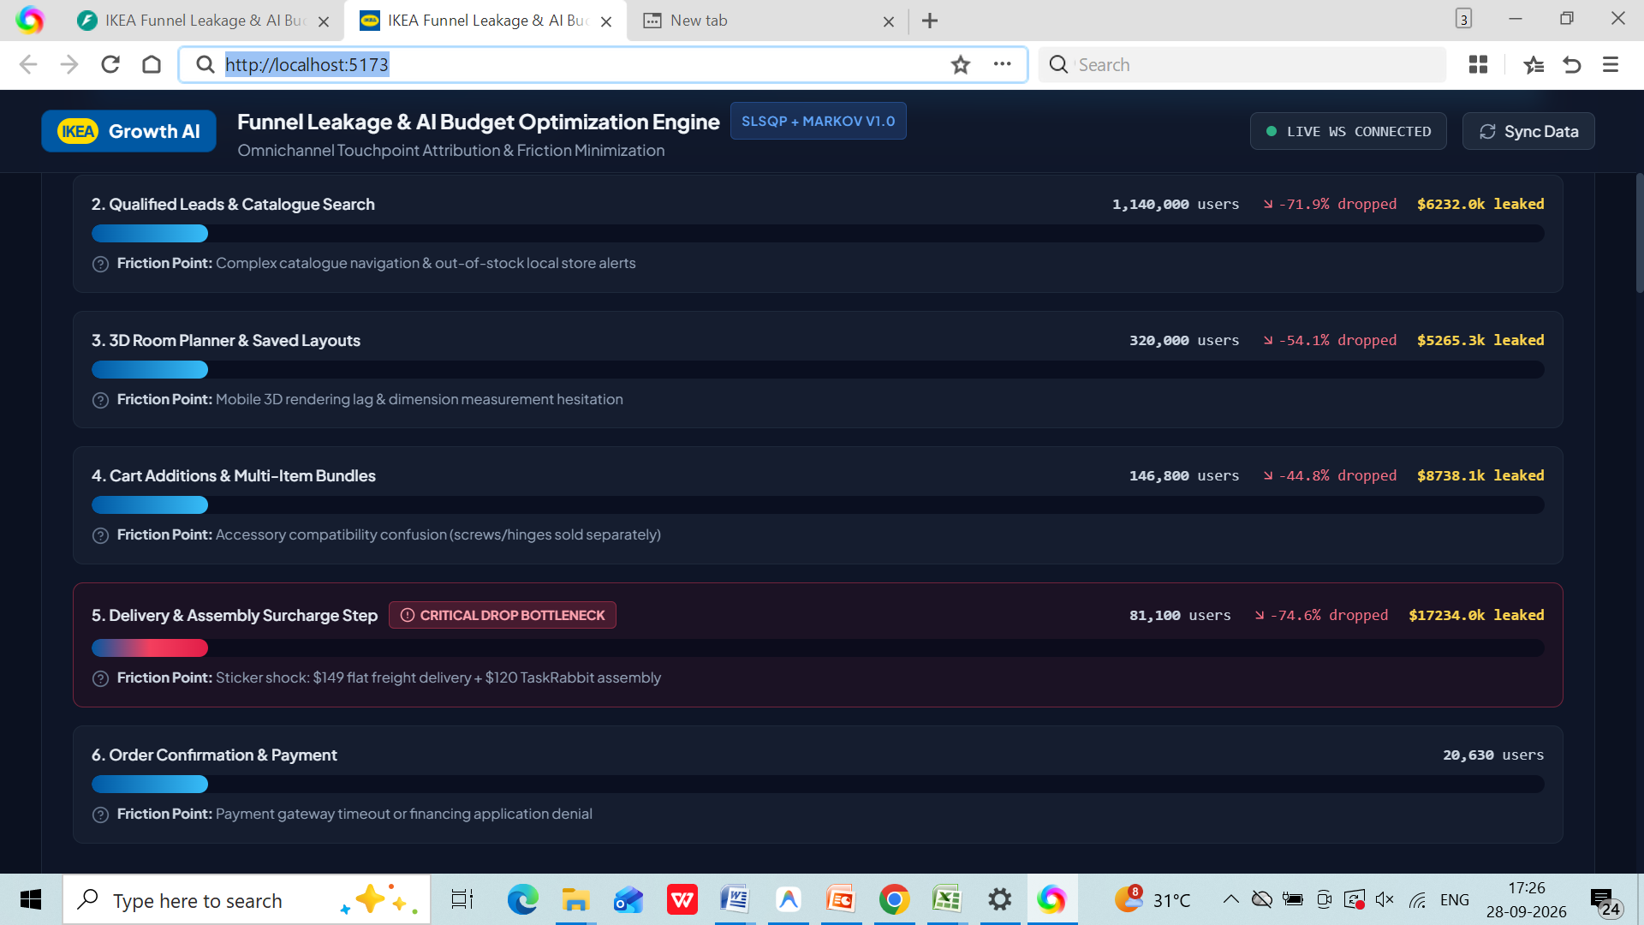
Figure 2. Funnel stages, retained users, drop-offs and estimated leakage.

4. Channel Drop-off Rate & Leakage Cost Analysis
The channel table compares six marketing touchpoints using spend, leads, purchases, conversion rate, LTV:CAC and leakage cost. This enables the dashboard user to distinguish between channels that generate volume and channels that generate economically valuable downstream outcomes.
Channel | Spend | Leads | Purchases | Conv. Rate | LTV:CAC | Leakage Cost | Primary Drop Stage
Social Media Inspiration (Insta/TikTok) | $120,000 | 240,000 | 1,200 | 0.50% | 4.5x | $2292.5k | Cart → Checkout
TV & OOH Billboard Campaigns | $150,000 | 170,000 | 950 | 0.56% | 3.93x | $2569.6k | Awareness → Lead Search
IKEA Kreativ AR 3D Room Planner | $75,000 | 195,000 | 4,200 | 2.15% | 64.4x | $4426.6k | Checkout → Assembly Cost
Google Shopping & Search Ads | $90,000 | 260,000 | 5,100 | 1.96% | 44.2x | $3160.8k | Cart → Checkout
IKEA Family CRM & Retargeting | $35,000 | 185,000 | 8,200 | 4.43% | 339.71x | $2970.2k | Loyalty Retention Loop
Influencer Room Makeovers (UGC) | $30,000 | 90,000 | 980 | 1.09% | 16.99x | $1032.6k | Inspiration → Design Save
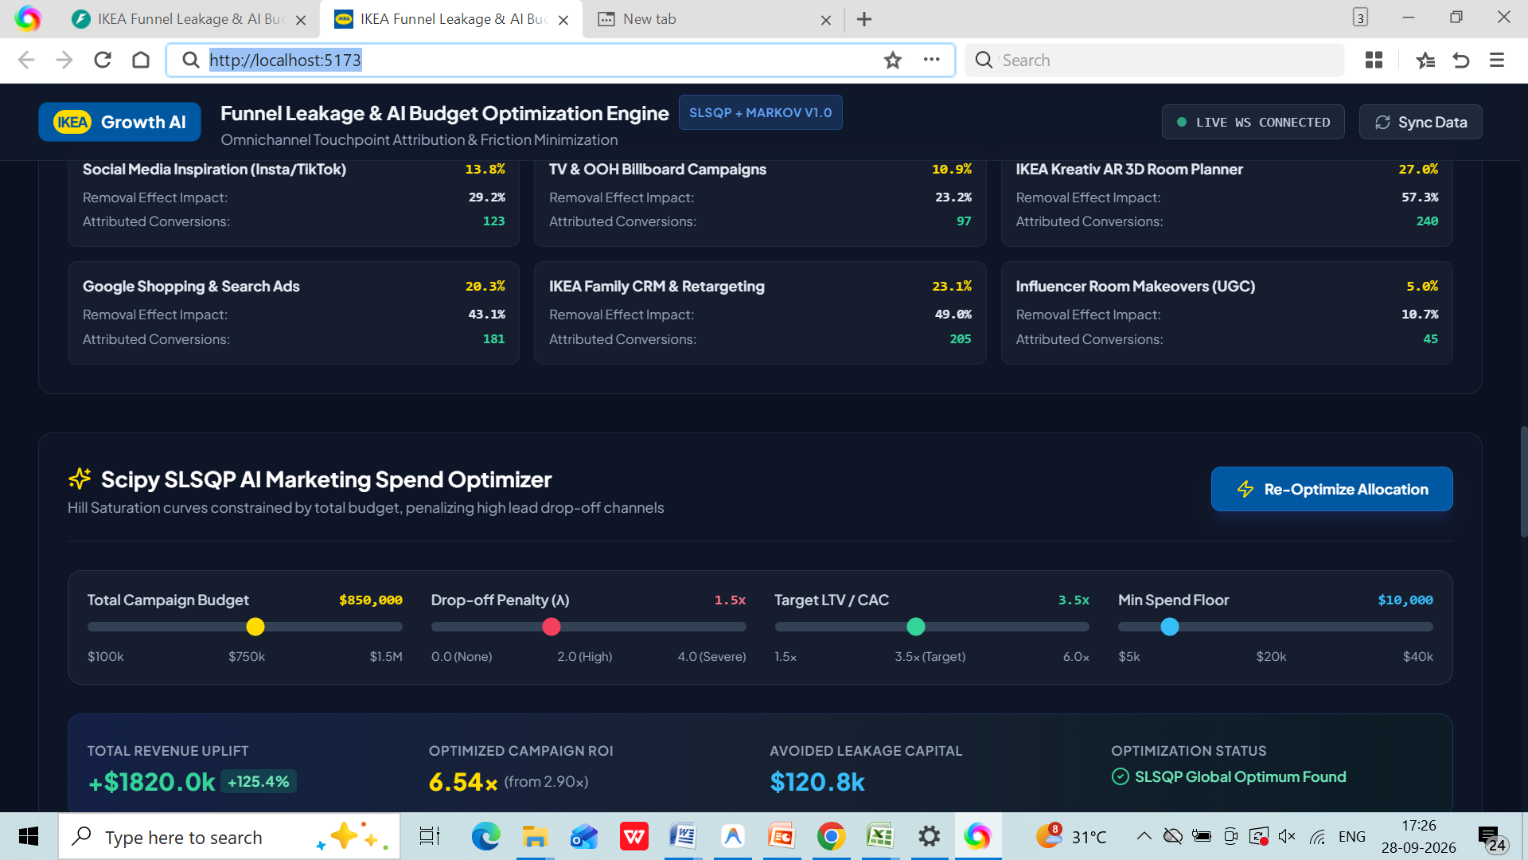
Figure 3. Channel drop-off rate and leakage cost summary.

4.1 Channel-Level Findings
The displayed metrics show large differences in conversion efficiency. IKEA Family CRM & Retargeting has the highest displayed conversion rate at 4.43% and the highest LTV:CAC at 339.71x. IKEA Kreativ AR 3D Room Planner also shows a high LTV:CAC of 64.4x and a 2.15% conversion rate. Google Shopping & Search Ads shows 1.96% conversion and 44.2x LTV:CAC.
By comparison, Social Media Inspiration and TV & OOH show conversion rates of 0.50% and 0.56%, respectively. The dashboard therefore flags these channels for leakage reduction within its optimization logic. Influencer Room Makeovers has a 1.09% conversion rate and 16.99x LTV:CAC, while still being flagged for budget reduction.

5. Markov Chain Removal Effect Attribution
The Markov attribution section is intended to address the limitations of single-touch attribution. It compares the model's removal-effect contribution with first-touch and last-touch weights. The removal effect estimates how much downstream conversion probability changes when a particular touchpoint is removed from the customer journey.
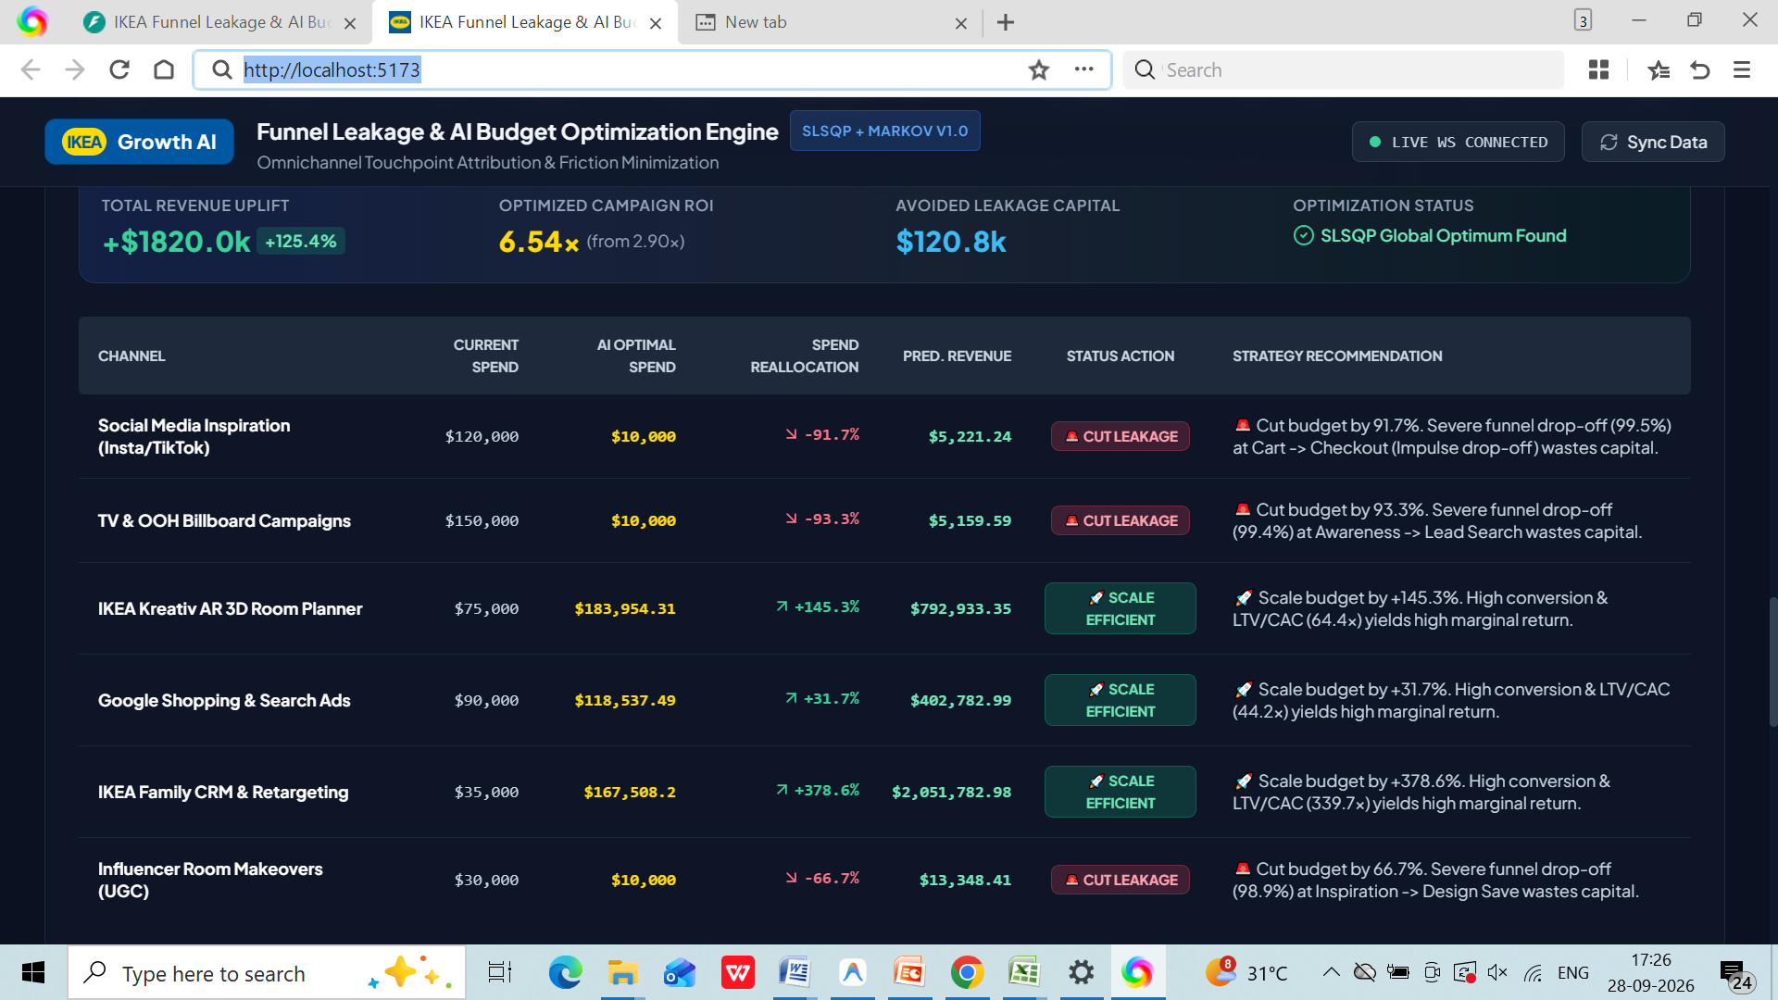
Figure 4. Markov removal-effect attribution compared with first-touch and last-touch weights.
A key displayed finding is that the IKEA Kreativ 3D Room Planner receives a substantially larger removal-effect contribution than its first-touch and last-touch weights suggest. The dashboard states that eliminating the 3D Room Planner produces a 42.8% reduction in overall downstream conversion probability. This demonstrates why the dashboard uses multi-touch attribution rather than relying only on the final interaction.

6. Hill Saturation Response Curves & Diminishing Returns
The Hill response curve models the relationship between marketing spend and expected revenue while allowing for diminishing returns. The curve rises quickly at lower spending levels and progressively flattens as spend increases. This helps the optimization engine identify operating points where additional spending becomes less efficient.
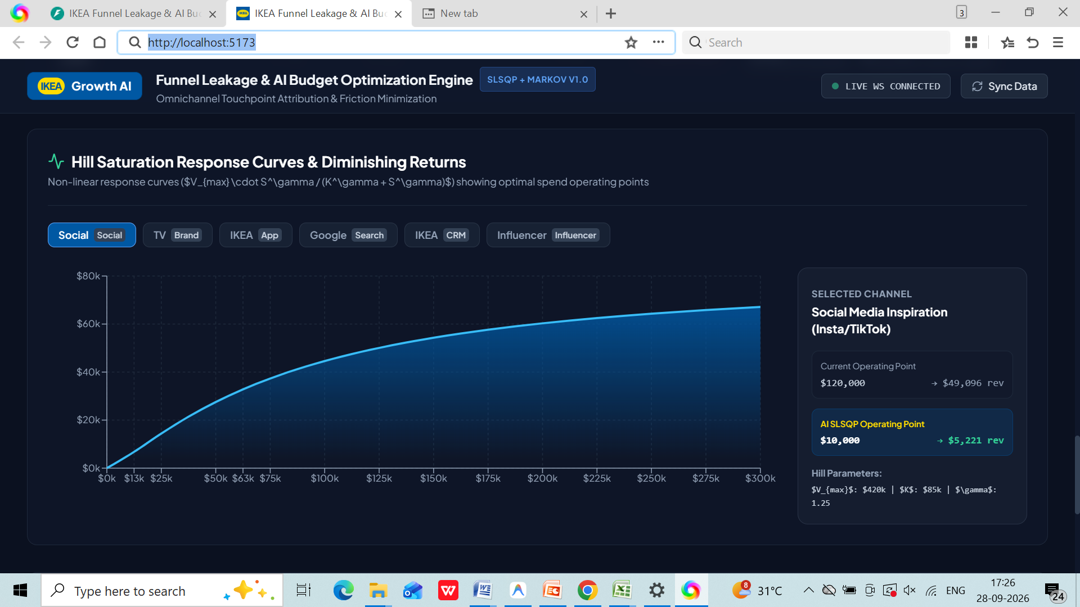
Figure 5. Hill saturation response curve for the selected Social Media Inspiration channel.
For the selected Social Media Inspiration channel, the dashboard displays a current operating point of $120,000 producing approximately $49,096 revenue, while the AI SLSQP operating point is $10,000 producing approximately $5,221 revenue. The curve illustrates the model's assumption that very high spend does not continue to generate proportional revenue.

7. AI Marketing Spend Optimization
The Scipy SLSQP AI Marketing Spend Optimizer combines budget constraints, drop-off penalties, target LTV/CAC and minimum spending floors. The displayed configuration uses a total campaign budget of $850,000, a drop-off penalty of 1.5x, a target LTV/CAC of 3.5x and a minimum spend floor of $10,000.
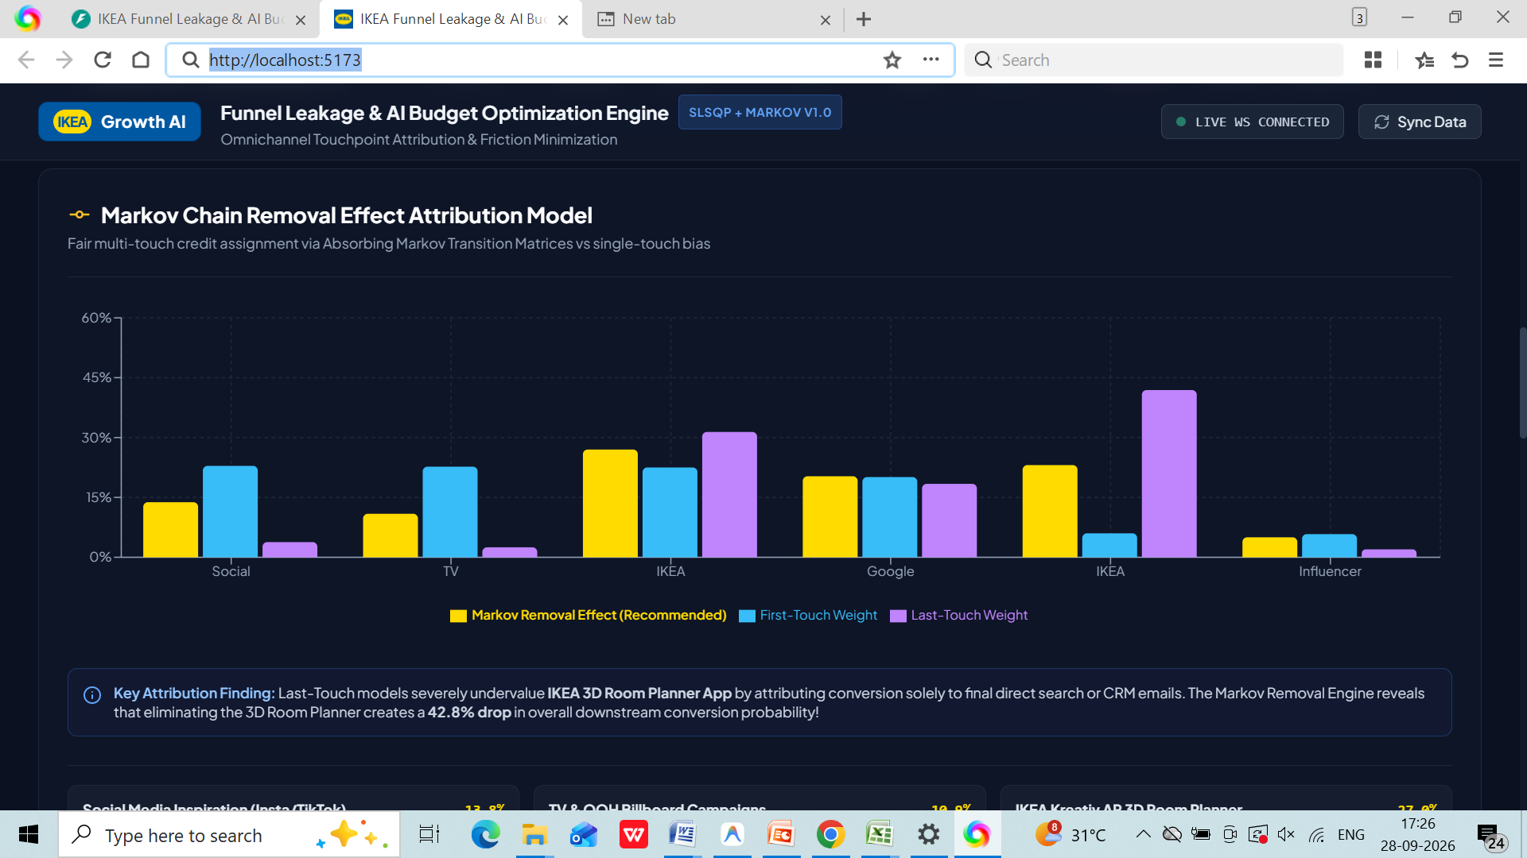
Figure 6. AI optimization controls and headline optimization results.
The displayed optimization result reports total revenue uplift of +$1,820.0k (+125.4%), optimized campaign ROI of 6.54x compared with 2.90x, and avoided leakage capital of $120.8k. The dashboard labels the outcome as 'SLSQP Global Optimum Found.' These figures should be interpreted as model outputs under the displayed assumptions and constraints rather than guaranteed future financial results.

7.1 Recommended Allocation Changes Shown by the Dashboard
Channel | Current Spend | AI Optimal Spend | Reallocation | Pred. Revenue | Status
Social Media Inspiration | $120,000 | $10,000 | -91.7% | $5,221.24 | Cut leakage
TV & OOH Billboard Campaigns | $150,000 | $10,000 | -93.3% | $5,159.59 | Cut leakage
IKEA Kreativ AR 3D Room Planner | $75,000 | $183,954.31 | +145.3% | $792,933.35 | Scale efficient
Google Shopping & Search Ads | $90,000 | $118,537.49 | +31.7% | $402,782.99 | Scale efficient
IKEA Family CRM & Retargeting | $35,000 | $167,508.20 | +378.6% | $2,051,782.98 | Scale efficient
Influencer Room Makeovers | $30,000 | $10,000 | -66.7% | $13,348.41 | Cut leakage
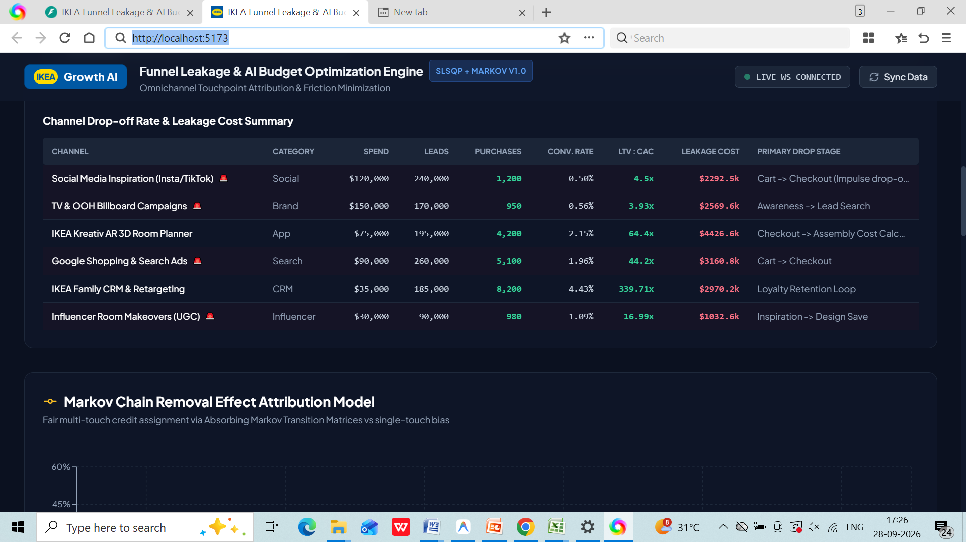
Figure 7. AI-optimized channel allocation, predicted revenue and strategy actions.

8. Real-Time Omnichannel Journey Event Stream
The real-time event stream demonstrates how the dashboard can be used as an operational monitoring layer in addition to a strategic planning tool. Events include assembly surcharges, cart reviews, 3D Room Planner activity and catalogue-search abandonment. Each event includes a timestamp, value and location.
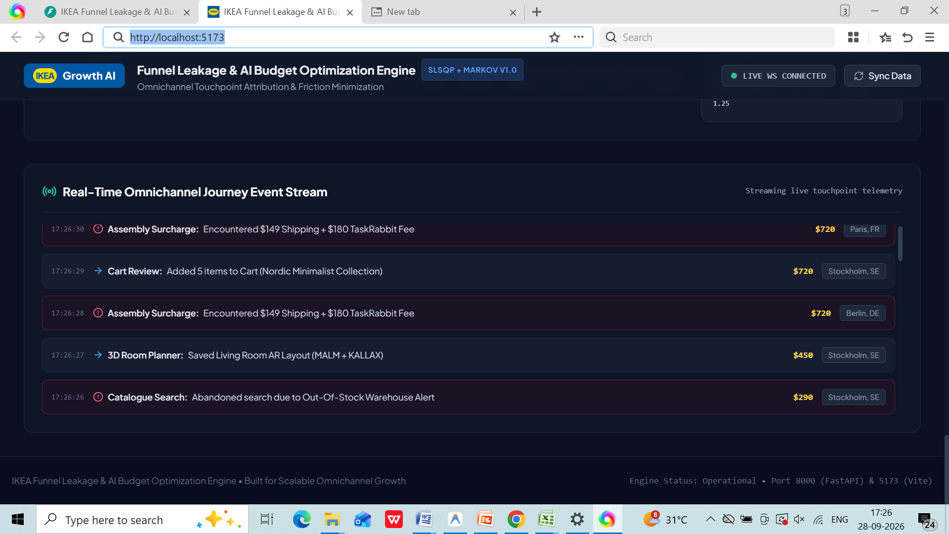
Figure 8. Real-time omnichannel journey event stream.
The displayed examples include an assembly surcharge event involving $149 shipping and a $180 TaskRabbit fee, a five-item cart review in Stockholm, a saved living-room AR layout, and a catalogue search abandoned because of an out-of-stock warehouse alert. These events align with the friction points identified in the funnel model.

9. Attribution and Channel Contribution
The dashboard's attribution cards report each channel's removal-effect impact and attributed conversions. The displayed values are:
Channel | Displayed contribution | Removal-effect impact | Attributed conversions
Social Media Inspiration | 13.8% | 29.2% | 123
TV & OOH Billboard Campaigns | 10.9% | 23.2% | 97
IKEA Kreativ AR 3D Room Planner | 27.0% | 57.3% | 240
Google Shopping & Search Ads | 20.3% | 43.1% | 181
IKEA Family CRM & Retargeting | 23.1% | 49.0% | 205
Influencer Room Makeovers | 5.0% | 10.7% | 45
These figures reinforce the dashboard's distinction between observed conversion credit and the estimated incremental importance of a touchpoint. In particular, the 3D Room Planner has a 27.0% displayed contribution and 57.3% removal-effect impact, illustrating its strong role in the modeled customer journey.

10. Dashboard Design & Usability Assessment
Visual hierarchy: Large KPI cards, section headings and highlighted status badges make the analytical flow easy to scan.
Color coding: Blue is used for primary analytical visuals, green for positive/scale actions, yellow for key model values and red/pink for leakage or risk indicators.
Interactivity: The channel tabs, Sync Data control and Re-Optimize Allocation button indicate an interactive analytical workflow.
Information density: The dashboard contains substantial information. The use of sections and cards helps organize it, although some tables and labels are dense.
Decision support: The dashboard connects descriptive metrics to actions, such as cut-leakage and scale-efficient recommendations.
Real-time capability: The live WebSocket status and event stream indicate support for continuously updated journey telemetry.

11. Business Recommendations Based on the Dashboard
- Investigate Delivery & Assembly pricing friction first because the dashboard identifies this stage as a 74.6% drop-off bottleneck and associates it with substantial displayed leakage.
- Improve catalogue availability and local-store inventory visibility to reduce abandonment caused by out-of-stock alerts.
- Evaluate the customer experience of the IKEA Kreativ 3D Room Planner, including mobile rendering and measurement guidance, while preserving its strong modeled contribution.
- Use Markov removal-effect attribution when evaluating channels so that high-value assisting touchpoints are not undervalued by last-touch reporting.
- Test the proposed budget reallocation in controlled increments rather than treating model outputs as guaranteed results. Compare realized conversion, revenue and LTV:CAC against the model's projections.
- Use the real-time event stream to connect operational friction events with downstream funnel outcomes and prioritize recurring issues.

12. Limitations and Considerations
The report is based on the values visible in the supplied dashboard screenshots. The underlying dataset, model training data, transition matrix, optimization code and statistical validation were not provided in this report. Therefore, the figures should be treated as dashboard/model outputs rather than independently audited business results.
The optimization outputs depend on assumptions such as the Hill saturation parameters, drop-off penalty, target LTV/CAC, minimum spend floor and total campaign budget. Changes to these inputs can change the recommended allocation.
Before implementation, the organization should validate the model against historical holdout data or controlled experiments and monitor actual incremental revenue, conversion rate, customer acquisition cost and retention.

13. Conclusion
The IKEA Funnel Leakage & AI Budget Optimization Engine provides an integrated view of customer journey performance, marketing attribution and budget allocation. Its central contribution is the linkage between funnel leakage and investment decisions: the dashboard identifies where customers are lost, estimates the economic impact and then uses attribution and response-curve modelling to propose a revised allocation.
The displayed results point to substantial differences in channel efficiency and highlight Delivery & Assembly as a critical customer-experience friction point. The combination of Markov attribution, Hill saturation modelling and SLSQP optimization makes the dashboard suitable as a decision-support prototype for omnichannel marketing planning, provided that the model assumptions and outputs are validated against real business data.

Appendix A – Dashboard Screenshots
Appendix Figure A1. Supplied live-dashboard screenshot.
Appendix Figure A2. Supplied live-dashboard screenshot.
Appendix Figure A3. Supplied live-dashboard screenshot.
Appendix Figure A4. Supplied live-dashboard screenshot.
Appendix Figure A5. Supplied live-dashboard screenshot.
Appendix Figure A6. Supplied live-dashboard screenshot.
Appendix Figure A7. Supplied live-dashboard screenshot.
Appendix Figure A8. Supplied live-dashboard screenshot.

14. Project Resources & Access Links
Live Dashboard: http://localhost:5173
GitHub Repository/Profile: https://github.com/ankitasaha03
The live dashboard link provides access to the locally hosted interactive dashboard used for the analysis. The GitHub link provides access to the project code and related implementation materials.
Resource | Link
Live Interactive Dashboard | http://localhost:5173
GitHub | https://github.com/ankitasaha03

Appendix B – Project Access
For demonstration and evaluation, the dashboard can be launched locally and accessed through http://localhost:5173. The source implementation and project files can be accessed through the GitHub profile provided above.

